Sticky Fish pre-school.
Special Educational Needs and Disability Policy.
To be read in conjunction with the settings Equal Opportunities Policy and with due regard to the SEND code of practice, 2014 and the Early Years Foundation Stage (EYFS).

Aims:
Sticky Fish preschool aims to provide inclusive play and learning opportunities for all children. Staff, student and volunteers with additional needs will be welcomed and supported appropriately. Staff and children are supported so that we can welcome diversity. Children with additional needs and gifted children have access to broad and balanced opportunities within the EYFS. They are included in all the activities within our setting by providing differentiated tasks and activities. We work in partnership with all involved.

Special Educational Needs coordinator (SENDCO)
Jo Ball is the person with responsibility for this role.
Contact details 0117 9584075
stickyfishpreschool@hotmail.co.uk

Responsibilities of SENCO:
- To attend five training sessions provided for newly appointed SENDco’s by the Bristol inclusion team, before or within the first year after their appointment to this role.
- To work in partnership with parents, offer them information which is clear and accessible, support them during their child’s time at Sticky Fish and through periods of transition. Where possible parents will be given time to discuss matters without prior arrangement either with their child’s key worker and/or Senco.
- To ensure all current and future staff and volunteers are familiar with the SEND framework and subsequent responsibilities
- To provide information for the staff and to support them in identifying the children who need extra help to access play and learning opportunities within the setting.
- To continue, when needed, to implement the revised graduated approach (SEN support) process of early years action and early years action plus.
- To ensure that appropriate reviews and next steps are in place, monitored and reviewed.
- To ensure that all review targets (where appropriate) are discussed at the next staff meeting following a child’s review meeting and the child’s progress is discussed regularly at subsequent staff meetings (where appropriate).
- To ensure parents of children with SEN and disabilities are aware of the support available to them and how to access it - signposting
- To involve parents and where appropriate, children in the decision making process
- To maintain records on the children and be a channel of communication between agencies.
- To initiate action with other agencies as appropriate in respect of the SEN of any child within the setting.
- To complete all paperwork needed when applying for support funding and supplying reports to outside professionals when requested
- Where appropriate additional time and work will be put into place in order to ease transition to other settings for children with additional needs, this is in addition to the transition work done for all children within the setting. This may include annual reviews with the new setting, supported visits to the new setting and a transfer of copies of all reports etc.

Identifying if a child needs extra support
As a setting we continually observe and assess the children both formally an informally.
Observations of children’s learning and development, recorded in individual learning diaries are accessible to parents and we have regular meetings with parents to discuss these. We continually monitor children’s progress and carry out more detailed assessments at key points through the year. We liaison with parent/carers.
We follow the graduated response when a child has been identified as needing extra support

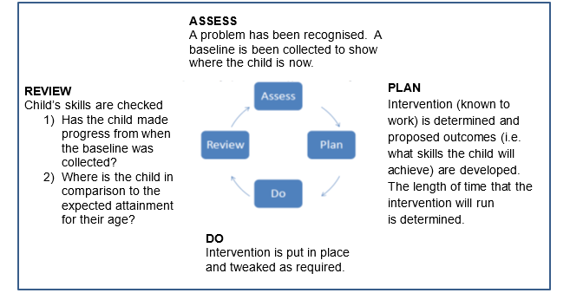

Admission arrangements:
Children’s individual needs will be discussed with their parent/carers and we will adapt and put things into place to meet those needs. We will be flexible during the settling in period so children can get to know us at their own pace.

Staffing and training:
The Senco and other staff have regular training and updates. When staff have been on relevant training this is then fed back to all staff through staff meetings.
As a staff we have had Makaton training. We also have a member of staff with BSL knowledge.
We will seek to offer and apply for the appropriate level of support for individual children. Our setting has a commitment to training in all areas of practice which includes relevant training for inclusion. We will seek advice, information and funding for training to help us support children with more complex needs.

Our approach to supporting different children’s needs, resources needed and the physical learning environment:
All children are valued as individuals and therefore careful consideration is given to the planning of learning to enable as much access as possible.

When a child/children have been identified as needing extra support this might be in the form of specific group/individual activities planned by a practitioner. For example, an adult playing alongside your child as your child plays using specific strategies, such as developing turn taking skills.

If needed support from outside professionals could be sought. For example: an Early Years Portage and Inclusion Specialist, a Speech and Language Therapist, Educational Psychologist, Occupational Therapist or Paediatrician. Specific, targeted strategies which reflect the advice given from an appropriate professional can then be used. These strategies may be carried out in a 1:1 situation, playing alongside your child or in a planned small group.

If a child has been supported as described above and has been identified as having a specific special educational need, we would discuss the development of a Support Plan (Non Statutory Education, Health and Care Plan) with parents/carers. The whole team supporting the child will be part of this.
We undertake careful planning to ensure language support is available to as many children with English as an additional language as possible.

If your child has a Support Plan (Non Statutory Education, Health and Care Plan) this will be reviewed three times a year. The progress children are making is compared to the targets set out in the plan. The targets are set by all the people, including professionals that work with the child.

We adapt our resources to suit the needs of the children. We have access to resources through toy libraries that specialise in inclusive play equipment.
We will make reasonable adjustments to our physical environment/equipment where necessary.
Our setting is accessible to all, including those who use wheelchairs. We have access to disabled toilets and changing facilities
The setting is light and airy with space for the children to move freely around the room independently, however, the ceiling is high and floors are wooden leading to poor acoustics. The outside area is accessible through double doors with access ramp.

